iCSee Three Lens Wifi Camera

Model: BT-HD65X-WF-SL

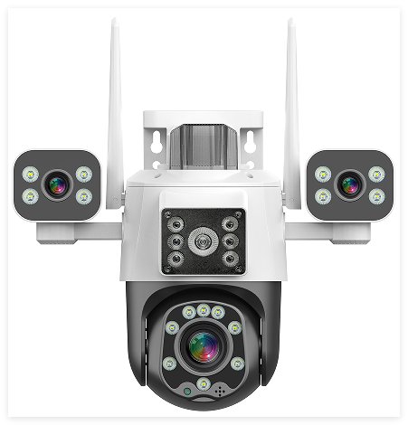
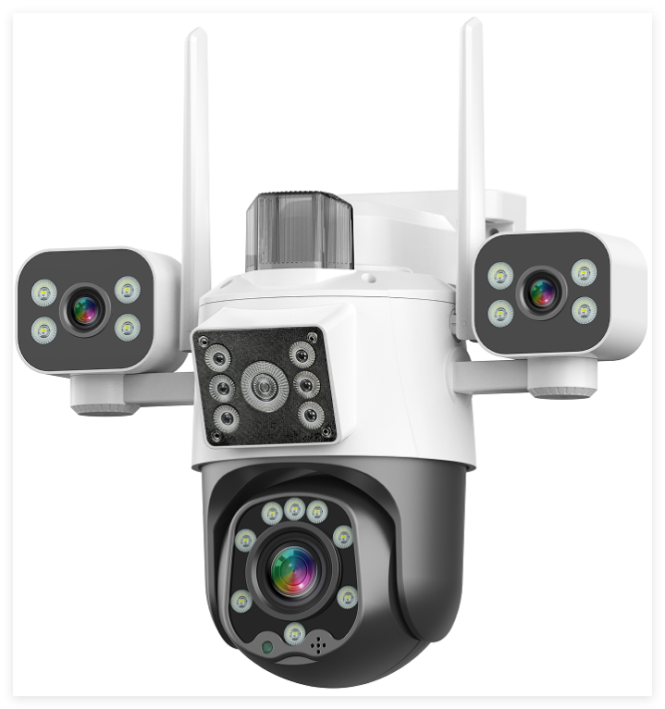

Features：
- 3 Inch PT three lens smart wifi camera, IP66
- Three sensor three view image in one screen, ultra wide angle vision
- AI human tracking, motion detection
- Built-in Mic & speaker, support two-way audio
- Built in TF card slot(max 512G)
- Dual light day & night full color vision
- Push notification to iPhone/Android APP
- App: iCSee

Technical Specifications
Model NO. | BT-HD65X-WF-SL
Camera
Image Sensor | 2MP 1/2.8" CMOS
Solution | XM535D1 + SC1346 *3
Mini Illumination | Color: 0.01Lux@F1.2(AGC ON), 0 Lux with IR  Black and White: 0.001 Lux @ (F1.2,AGC ON), 0 Lux with IR
Digital Noise Reduction | 2D/3D DNR
Image Settings | Image Flip
Function | remote monitoring; push message after human detection alarm; image capture
Lens
Lens | 4mm*3
Aperture | F1.8
Field of View | Diagonal 107.0° Horizontal: 89° Vertical: 48°
Rotation
Angle | Manual control of the rotation adjustment according to the scene to be monitored
Video
Image Output | Main Stream: 1280*720@12fps
Image Output | Sub-Stream: 640*360@12fps
Audio
Audio Compression | G.711; Support Two Way Audio
Al+
General | Human detection, Human tracking, Intrusion alarm
Alarm | SD card recording, APP alarm, Sound and light alarm
APP
Mobile View | Android, IOS ( iCSee)
Light
Warm Light Distance | Up to 15 m
IR Distance | Up to 15 m
LEDS | 4 PCS IR LEDS +4 PCS Warm LED  4 PCS IR LEDS +2 PCS Warm LED  4 PCS Dual Wick Lamps*2
Lighting mode | Starlight full color; Infrared night vision; Intelligent alert
General
Power Supply | DC 12V±25％
Power Connector | Φ5.5mm
Power consumption | ≤10w
Operating Conditions | (-20℃ ~ 45℃) humidity 95% or less (non-condensing)
Factory Data Reset | Support
Material | Plastic
Dimension | Product：255*185*206mm  Packing：260*210*190mm
Weight | Camera Net weight：660g
Accessory | screw kit x1, user manual x1
Dimension
